

Blade Server

TC6600

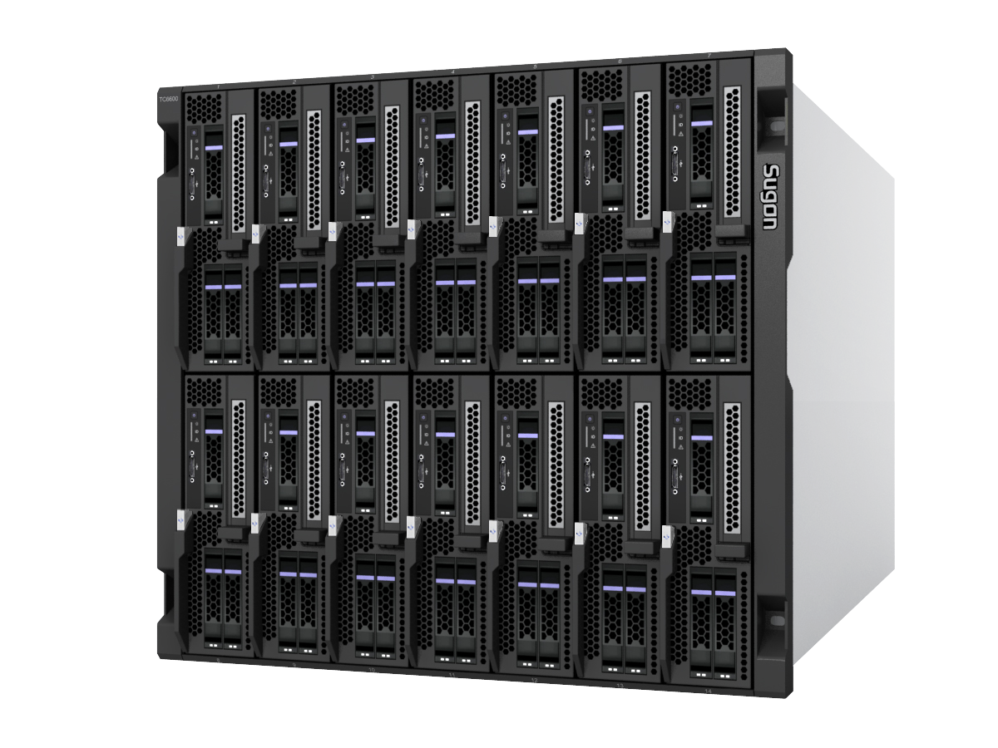

|  |
| --- |
| Our TC 6600 integrated-architecture blade server is a world-leading blade server product in consistence with the open standard of the latest generation of products. It has an integrated architecture, targeting on high-performance computing, integrated network architecture and virtualization, the product integrates multiple advanced design concepts and technological features.  TC 6600 integrated-architecture blade server is a type of 10U14 blade server; it realizes the design requirements of high performance, high density, expandability, on-demand configuration and flexibility. The product is able to meet the diverse and dynamically changing application demands of users. Meanwhile, TC 6600 has the RAS features of enterprise-class products, thus to meet the demands of critical users in the field of education, research institutes, cloud computing, security, government, petroleum, telecommunications, finance, meteorology, radio and television, Internet and so on.  TC 6600 integrated-architecture blade server has excellent system expandability; it can be configured flexibly according to actual demands. The system presently supports computing blades based on Intel Xeon E5-2600V3, Intel Xeon E7-4800V2 and AMD 6300 series of multi-core processor platform. A single blade can support maximum 14 computing nodes, and through modular design different network interfaces can be provided for the computing blade. The system supports 1Gb Ethernet, 10Gb Ethernet, 8G/16G FC network and the future 100G infiniband EDR network. For the critical components and functional modules of the system, TC 6600 adopts a redundant design, thus it realizes the RAS features at an enterprise level and can satisfy the needs of critical applications.  In system management, TC 6600 provides local BMC (IPMI), system CMM management module and large-scale cluster management software. Such a 3-level management strategy simplifies the deployment, operation and maintenance of the system to the largest extent and users can easily control the overall system.  TC 6600 applies multistep energy-saving measures: the efficiency of a single power is up to 94%; the product also adopts intelligent multi-module flow equalization measures to effectively reduce system power consumption and improve the power efficiency and cooling efficiency of the whole system; with energy-saving software, the environmental protection and energy saving effect can be maximized.  TC 6600 is a high-performance and high-density blade server system independently designed by Sugon. Its standard for openness and interfaces breaks monopoly and the “island”, provides the preconditions for the formulation of the industrial chain, users can get more choices and complete services with a reduced TCO. |

Features:

* Open standard
* Powerful expandability
* Convenient to manage
* Powerful computing ability
* On-demand configuration and flexibility
* Intelligent and efficient power and cooling strategies
* Environmental protection and energy saving

|  |
| --- |
| **Overview** |
| Complying with the open standard  TC 6600 is a high-density and high-performance blade server system independently designed by Sugon. The blade platform is in consistence with the open standard and brings benefits for users from different aspects, including conveniently selecting components and modules by different manufactures, protecting investments and reducing TCO.  Powerful and flexible network capabilities  TC 6600 provides flexible and powerful network capabilities. The system supports Gigabit Ethernet, Gigabit 10G Ethernet, 8G/16G FC network and the future 100G EDR network. The system provides a 10G network interface supporting configurations with corresponding 8G/16G FC network interface disk array, providing high-capacity disk integration solutions. Thus it can maximize the reliability of the disk system andsatisfy the demands for saving space, high-speed access to memory and protecting data of users to the largest extent.  Diverse disk configuration solutions  A variety of disk expansion methods are provided: the local disk blade can provide maximum 16 hard disks. Based on the local RAID controller, RAID 0, RAID 1, RAID 1E AND RAID 5 can be established.  Convenient system management  Local BMC (IPMI), system CMM management module and large-scale cluster management software are provided; the 3-level integrated management strategy enables the users to easily control the overall system and get familiar with system status.  Powerful computing capabilities  Intel Xeon E5-2600V3, Intel Xeon E7-4800V2 and AMD 6300 series of multi-core processor can be used to establish high-performance computing blades providing powerful computing capabilities.  On-demand configuration and flexibility  Based on changes in business demands, users can dynamically adjust the configurations of the blade server; products can be easily and conveniently upgraded to realize economical efficiency.  Efficient and intelligent power and cooling strategy  The power management can realize automatic equalization. Thus the power can be maintained in the most efficient state in all time and minimize the power consumption of users. The reasonably arranged cooling area can maximize the cooling efficiency and reliability.  In view of the dynamic changes in applications used by users, the system provides intelligent automatic optimization strategies for power and cooling.  Green energy saving  The product adopts advanced design concepts and a variety of energy saving measures to reduce system power consumption and improve the power efficiency and cooling efficiency of the system. With energy saving software, energy saving effect of the system is maximized. |

Features and advantages

Standard blade rack

The product has a standardized and modular design; its standard 10U rack can provide 14 blade bays. Low or high-speed network modules, management modules and computing blades by different manufacturers can be applied, and thus more product vendors are optional to users. Standard Modules from different periods can be used prolonging the life cycle of the blade system and protecting the users’ investments.

Functional features

Advantages

High-speed Infiniband switching network

The high-bandwidth, low-latency and fully interconnected Infiniband high-speed switching network is able to support infiniband 100Gb/s EDR network connection in the future, and support switching between copper cables and fiber optic connectors.

By using the latest EDR 100G infiniband switching network in this field with the highest performance, the blade rack is able to provide a transfer capacity up to 8.78Tb/s or 17.56Tb/s.

10G Ethernet

The system provides 10G-Ethernet interface; provides 24-port Gigabit switching and 48-port Gigabit switching to meet the bandwidth demands of high-performance computing, cloud computing and virtualization technology for basic guarantee; meanwhile, provides standard interfaces for 10G storage solutions and satisfies the diverse application demands of users for 10G network.

High-availability middle panel

The passive middle panel without active devices improves the reliability exponentially. The high-speed signals are designed in separation from the low-speed signals improving the reliability of the middle panel. The system also reserves an expansion link for the next generation of I/O technology to realize seamless upgrading and compatibility for the next generation of blade. The life cycle of the blade rack is prolonged and the initial investments of users can be effectively protected.



Gigabit Ethernet

Various Gigabit network modules with different specifications and performance

1. Regular gigabit switching network and 10-gigabit switching network to satisfy different application demands;
2. Gigabit straight-forward network to satisfy rigorous demands of users for network performance

Computing blade

The system provides a multi-core processor based on supporting for Intel Xeon E5-2600v3, Intel Xeon E7-4800V2 and AMD 6300. On the unified infrastructure platform of Sugon TC 6600, flexible options can be made.

Optimization choices can be selected according to special applications. Different computing blade platforms suitable for various application demands are stored in the unified blade rack to get the best overall integration solutions.

**Technical specifications**

The system uses SRPM (Self Regulating Power Modules)

Remote KVM function

It permits to visit, install, configure and control remote blade servers through Web browsers from the desktop or any other location; it lows demand for network bandwidth eliminating geographical constrain in managing and using the blade server system and improving the remote processing speed; BIOS access and control having no connect with operating system provides overall compatibility; high- security data is performed with 128-bit data encryption in the hardware.

Based on temperature changes, it linearly and smoothly adjusts the fans velocity, minimizes the noise level and reduces unnecessary power consumption.

Based on temperature changes, it predicts the change trend of the next stage; velocity adjustment compensation is performed in advance to ensure stable fans velocity and noise lowing.

LPCM（Linear Pre-Compensation Cooling Modules）

Intelligent power control without human intervention, SRPM maintains the power modules to work at the highest point of the efficiency curves to reduce unnecessary power consumption and significantly improve the life cycle of the power.

It supports real-time status monitoring, real-time power loads measurement and display.

8G/16G FC network

Advantages

Functional features

It provides storage interfaces supporting 8G/16G fibers to satisfy bandwidth demands of high-performance computing, cloud computing and virtualization technology for basic guarantee; it provides standard interfaces for 8G/16G storage solutions to satisfy diverse application demands of users for storage network.

Management module provides FVMM（Full View Management Modules）

Based on Web browser, it provides the latest status of all components and detailed information about graphics; it provides strategies, such as real-time status monitoring, faults warning, dynamic optimization, adjustment of resource allocation and working; storing and analyzing critical historical data, visually displaying changing trends of important information; Different faults warning modes to check logs, audits and reports. Encrypted remote control is permitted to control, operate and monitor the overall operation conditions from any point. Remote KVM is permitted to stay away from the noisy environment of the machine room.

Redundancy design

The redundancy design is used in system critical components and modules of TC 6600, including the power module, network module, and fans module to ensure highly reliable operation of the unit.

OPSI (Optical Path Status indicator)

OPSI covering various components of the blade server can provide accurate status indication and false alarm to help user to understand the operation conditions of the system, rapidly make judgment and positioning to abnormalities. It provides stable services and realizes the best MTBF.

Remote virtual medium

Providing virtual medium for each computing blade used in installing operating systems, copying documents and other operations. With remote KVM and Web interface management, the system can realize comprehensive remote management and controlling; using medium to bring convenience for installing operating system and data copying.

**Advantages**

**Functional features**

|  |  |
| --- | --- |
| Technical specifications for TC6600 blade server | |
| Appearance features of blade server rack | 10U standard rack height |
| Blade system | 14 half-height slots or 7 full-height slots, supporting flexible combination; with the design of passive backplane, the redundancy design is used in system critical components, including the power module, fan module, blade I/O interfaces and blade chassis module. |
| Types of computing blades | 1. 14 2-way half-height computing blades based on Intel Xeon E5-2600v3 platform are optional. 2. 2-way full-height computing blades based on Intel Xeon E5-2600V3 platform are optional. 3. 7 4-way full-height computing blades based on Intel Xeon E7-4800V2 platform are optional. 4. 7 4-way full-height computing blades based on AMD 6300 platform are optional. |
| 10G Ethernet switching module | 1, The rack system supporting 4 10G Ethernet switching modules.  2, supporting 5Tbps-switching throughput (max). |
| 10G  Ethernet straightforward module | 1. The rack system can be configured to support four 10G Ethernet switching modules. 2. Each 10G Ethernet straightforward module is configured with   Configuration:14×10GE downstream ports， 14×10GE upstream-external ports |
| Power Module | 6 hot-swap 2000W AC power modules with load balancing and faults switching functions can be configured; N+1 or N+N power redundancy configuration can be provided; power efficiency: 94% |
| Cooling module | Standard 10 sets of intelligent redundancy fans with linear pre-compensation functions. |
| Management module | 1+1 redundant management modules can be provided; each management module can realize overall management controlling and monitoring functions, including remote virtual medium, remote KVM, blade status, false positioning, startup and shutdown, etc. |
| Supporting medium | One external USB DVD-RW; one USB Hub |
| OPSI | Blade rack, blades, power, KVM, USB, IB network, Gigabit network, senior management module, hard disk driver |
| External memory | Supporting mainstream storage solutions (all Sugon storage products) and non-Sugon storage products. |
| Dimensions（H×W×D） | 444.5mm×446mm× 792mm； |
| Weight (All furnished) | 50Kg (excluding computing blades) |

Technical specifications for computing blades

|  |  |
| --- | --- |
| CB50-G20 2-way Intel Xeon E5-2600V3 blade | |
| Blade status | Half-height 2-way blade computing nodes |
| Processor | Supports Intel Xeon E5-2600 V3 series of processors |
| Processor quantity | 2(Max), 1 can be selected |
| Memory | Supports memory: DDR4, 2133/1866/1600 Mhz |
| Chip sets | Intel Patsburg C610 series of high-end chip sets |
| SAS Controller | LSI 3008 SAS controller provides RAID 0, RAID 1 and so on. |
| Disk | Provides 2.5” local hot-swap SAS/SATA/SSD disks optional configurations:  Option 1: 3 HDD+PCI-E standard slot expansion  Optional 2: 4 HDDs |
| RAID supporting | LSI 3008 SAS controller provides RAID 0, 1, 1E; |
| PCI-E expansion | Supports to expand 2 Mezz buckles and also supports to expand 1 PCI-E standard card  Types of Mezz buckles: 4-port Gigabit, 2-port 10-Gigabit, 2-port FC, 4-port 10-Gigabit, 4-port FC； |
| Local board-mounted Gigabit network | Intel I350 2-port Gigabit Ethernet controller supporting virtualization and IO acceleration. |
| VGA | Integrated graphics controller AST2400 and memory size 16MB |
| System management | Board-mounted BMC management chip, consistent with the management functions specififed in standard IPMI 2.0, provides remote IKVM, Virtual Media functions. |
| Dimensions（H×W×D） | 210.90mm×59.4mm×538.40mm |
| Weight (all furnished) | 5Kg； |
| Compatible operating system (for detailed version information, please refer to the software compatibility list of TC 660 blade server) | Windows Server 2008 R2 SP1 64bit  Redhat Enterprise Linux 6U5 64bit  SUSE Linux Enterprise Server 11 SP3 64bit  Compatibility of operating system is significantly associated with the system configuration. For more information, please consult the sales representatives of Sugon or Sugon customer service hot lines. |

Technical specifications for computing blades

|  |  |
| --- | --- |
| CB80-G20 4-way Intel Xeon E7-4800V2 blade | |
| Blade status | Full-height 4-way blade computing nodes |
| Processor | Supports Intel Xeon E7-4800 V2 series of processors |
| Processor quantity | Maximum 4 |
| Memory | Provides 48 memory DDR3 DIMM slots |
| Chip sets | Intel Patsburg C602J series of high-end chip sets |
| SAS Raid Controller | LSI 3108 SAS controller, supporting 2G cache Raid, providing RAID 0, 1，10，5, 50, 6, 60; |
| Disk | Provides 2.5” local hot-swap SAS/SATA/SSD disk configurations |
| PCI-E expansion | Supports to expand 4 Mezz buckles  Types of Mezz buckles: 4-port Gigabit, 2-port 10-Gigabit, 2-port FC, 4-port 10-Gigabit, 4-port FC； |
| Local board-mounted Gigabit network | Intel I350 2-port Gigabit Ethernet controller supports virtualization and IO acceleration. |
| VGA | Integrated graphics controller |
| System management | Board-mounted BMC management chip, consistent with the management function of IPMI 2.0 standard, provides remote IKVM, Virtual Media functions. |
| Dimensions（H×W×D） | 421.80mm×59.4mm×538.40mm |
| Weight (all furnished) | 12Kg； |
| Compatible operating system (for detailed version information, please refer to the software compatibility list of TC 660 blade server) | Windows Server 2008 R2 SP1 64bit  Redhat Enterprise Linux 6U5 64bit  SUSE Linux Enterprise Server 11 SP3 64bit  Compatibility of the operating system is significantly associated with the system configuration. For more information, please consult the sales representatives of Sugon or Sugon customer service hot lines. |

Technical specifications for computing blades

|  |  |
| --- | --- |
| CB85-G10 4-way AMD Opteron 6300 blades | |
| Blade status | Full-height 4-way blade computing nodes |
| Processor | Supports AMD Opteron 6300 series of processors（supports 140W CPU ）； |
| Processor quantity | Maximum 4 |
| Memory | Provides 32 memory DDR3 DIMM slots |
| Chip sets | AMD SR5690 series of high-end chip sets |
| SAS Controller | LSI 3108 SAS controller and supports 2G cache Raid，  Provides RAID 0，1，10，5, 50, 6, 60; |
| Disk | Provides 4 local HDD 2.5” hot-swap SAS/SATA/SSD disk configuration |
| PCI-E expansion | Supports to expand 4 Mezz buckles  Types of Mezz buckles: 4-port Gigabit, 2-port 10-Gigabit, 2-port FC, 4-port 10-Gigabit, 4-port FC； |
| Local board-mounted Gigabit network | Intel I350 2-port Gigabit Ethernet controller supports virtualization and IO acceleration. |
| VGA | Integrated graphics controller AST2400; MB: 16MB； |
| System management | 421.80mm×59.4mm×538.40mm |
| Dimensions（H×W×D） | 12Kg； |
| Weight (all furnished) | Windows Server 2008 R2 SP1 64bit  Redhat Enterprise Linux 6U5 64bit  SUSE Linux Enterprise Server 11 SP3 64bit  VMware ESXI 5.X  Compatibility of the operating system is significantly associated with the system configuration. For more information, please consult the sales representatives of Sugon or Sugon customer service hot lines. |

|  |
| --- |
| **For more information:**  Please visit official Sugon website: www. Sugon.com or dial the customer service hot line: 400-810-0466  You can also contact Sugon branches distributed throughout the state. Please log in the official website of Sugon for contact information.  Sugon reserves the right to modify the product specifications or other product information (including, but not limited to weights, appearance, dimensions or other physical elements) without any further notification.  Any changes of information involved in the document caused by products upgrading or other causes, no additional notification will be provided. All product graphics involved in the document shall be subject to the physical products. |